Parish of Seapatrick, Banbridge
Sacrament of Baptism
Enquiry Form

Please complete this form and return to seapatrickparish@dromorediocese.org

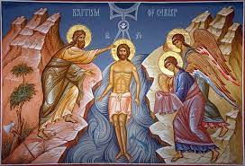
Name of Child:
Date of Birth:
Address:

Postcode:
Telephone/Mobile No
Father’s Full Name:
Mother’s Full Name:
Mother’s Maiden Name: (if applicable)
Date of Marriage: (if applicable)
Church of Marriage, including Parish: (if applicable)
Godfather’s Name:
Godmother’s Name:

I would like a visit from the Baptismal Team: Yes ☐ No ☐
I would like my child’s name included in the weekly Parish Bulletin:
Yes ☐ No ☐
Signature of Celebrant:
Choosing a Godparent

When choosing a godparent for your baby please note they must be baptized and confirmed and at least 16 years of age.
While two godparents are not strictly required, if you are choosing two, these must be one man and one woman.

To be completed by Parish Office Staff:

Reference No:

Church:
Date:
Time:
Celebrant:

Recorded in Baptism Register:
Recorded in Digital Register:
Recorded in Family Information:

